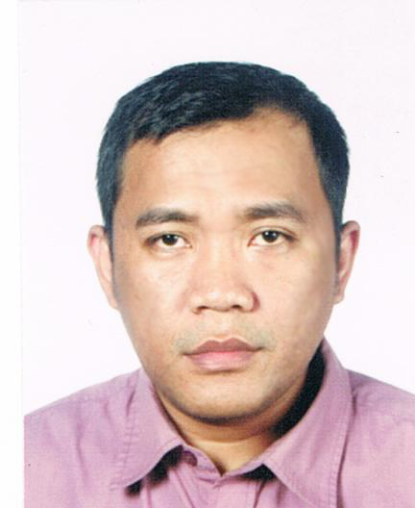

Joseph G. Sausa
Blk. 29 Lt. 16 Rancho Imperial Subd.
Ph. 2, Tartaria, Silang, Cavite
Passport #: SS0434170
Driver’s license #: D18-04-005115
Cel. # 09198770309
Email: scorpthur08@yahoo.com

OBJECTIVE : To be a part of your equipment/preventive maintenance group or any related

field where my past experience may shared not only for my personal growth but also for the fulfillment of the company’s goal.

WORK EXPERIENCE:

- Integrated Microelectronics Inc. - Standard Semi-Custom Group
Position: Equipment Technician IV - Chip on Board Area
January 2002-present

- Electronic Assemblies, Inc.
Position: Equipment Technician IV - Chip on Board Area
January 2001-Dec. 2001

- Electronic Assemblies, Inc.
Position: Line maintenance technician II
Jan. 1998- Dec. 2000

- Electronic Assemblies, Inc.
Position: Preventive maintenance technician I
July 1995- Dec. 1997

Duties and Responsibilities:
- Repair and troubleshoots machine to insure continues production operation.
- See to it that all machines in the area are effectively use by production and checks if the standard parameters of every machine are being followed.
- See to it that proper Preventive Maintenance activities are being followed base on the given schedule and documents specification.
- Sets safety measures on the line.
- Reports major concerns in the area of responsibilities.
- Perform equipment preventive maintenance and calibration.
- Supervises equipment technicians.
- Performed other function as may be assigned.

Skills:
- Electronic manufacturing and Semiconductor equipment programming, sustenance and preventive maintenance.
- Knowledge in PLC, pneumatics and automated equipment.
- Desktop, Laptop computer servicing trouble-shooting, repair, hardware and software installation.
- Install computer systems and networks.
- Diagnos and trouble-shoot computer system.
- Configure, maintain computer systems and network.
- Terminate and connect electrical wiring and electronics circuits.

Machine Handled:

- ASM Eagle Extreme Gold Wirebonder
- ASM AB559,AB509 Aluminum Wedge bonder
- Yamaha I-Cube die-attach machine
- K&S 1476,1470 Semi-automatic Aluminum Wedge bonder
- Protec FDS1010/1000 Dispenser.
- Keyence Laser Marking machine
- Asymtek Century series, CAM/ALOT Automatic Dispenser
- Royce Wire-pull tester, Dage 4000 Wire-pull tester
- ZEBRA label/barcode printer
- SAYAKA, LARKEN, Ellite PCB Router machine
- Panasert MV2V/MV2F/MSR Pick and Place
- Yamaha YVL88, YV100/ Panasonic Create CM202, CM402 Chip mounter
- Pansert MPAV, Panasonic Create CM301, CM401 IC placer
- Dek ELA, 260, 248 / Minami/ Panasert SPPG3 Auto-screen print
- Heller reflow 1500W/1700W/1809
- YES TECH YTX-300 x-ray machine
- Electrovert Aquastorm Aqueous cleaner

EDUCATIONAL BACKGROUND:

BSET-Electronics Technology :Technological University of the Phillipines-Visayas
:Capt. Sabi St. Talisay City
Negros Occidental
Year Graduated :1995

SECONDARY :Dr. V. F. Gustilo Memorial Nat’l High School
Cabahug St., Cadiz City
Negros Occidental
Year Graduated :1990

PRIMARY :Progreso Elementary School
Bo. Luna, Cadiz City
Negros Occidental
Year Graduated :1986 (Valedictorian)

TRAININGS ATTENDED:

- ISO 9000, 9002, 14001 IMI VALUES
- FMEA 5’S
- Statistical Process Control
- 7QC tools
- Total Productive Maintenance

- Protec Dispenser Training
Protec Co., Ltd
#10 Block 10 Lot 10 Nam Dong Industrial Estate
623-9, Namchon-Dong, Namdong-gu, Incheon City, korea
March 29, 2010-April 02, 2010

- Introduction to PLC Technology using Simatics S7-200 PLC
A&D PT4 Training Center, Siemens Inc.
12th floor Salcedo Tower
167 H.V. dela Costa St., Salcedo Village, Makati City
Oct. 05, 2004

- Panasonic Create CM202, 301 Basic training
Create Technical Center
512 Chai Che Lane #01-06 Bedok Industrial Estate
Singapore
May 08-16 2002

- ASM AB559 Advance training
ASM Assembly Automation plant
4/F Watson Center 16 Kung Yip St.
Kwai Chung, Hongkong
Nov. 03-07, 1998

PERSONAL DATA:

Date of Birth : November 08, 1973
Place of Birth : Cadiz City Negros Occidental
Civil Status : Married
Nationality : Filipino
Sex : Male
Height : 5ft. 4 inches
Weight : 55 kgs.
Religion : Roman Catholic
Father’s Name : Rodolfo S. Sausa
Occupation : Retired Farm overseer
Mother’s Name : Erlinda D. Guarino
Occupation : Housewife
Language : English, Tagalog, Ilonggo
Vision : 20/20
Health : Exellent
Complexion : Brown

REFERENCES:

Rene C. Sandoval

Equipment Engineer
Integrated Microelectronics, Inc.
Cel. #: 09193200513
Email: Rene.Sandoval@ph.global-imi.com

Jeferson Sinon

Equipment Engineer
Integrated Microelectronics Inc
Cel. #:09287845366
Email: Jeferson.Sinon@ph.global-imi.com

